OS LAB INTERNAL TEST 1

S ROHIT RAM AY: 2022-2023

3122215001086

CSE-B

Q) SIMULATE THE FOLLOWING SYSTEM COMMANDS

1) mv a.txt b.txt

2) nl a.txt

1)

**CODE**

#include<stdio.h>

#include<stdlib.h>

#include<unistd.h>

#include <sys/types.h>

#include <sys/stat.h>

#include <fcntl.h>

void main(int argc,char* argv[])

{

int fd1,fd2;

fd1=open(argv[1],O_RDONLY); //system call to open file

if(fd1==-1) // if -1, file not opened

{

printf("error opening file 1");

}

fd2=open(argv[2],O_WRONLY | O_CREAT,00777); //system call to open file

if(fd2==-1) // if -1, file not opened

{

printf("error opening file 2");

}

int bytesrd,byteswr; //store bytes read, bytes written as return values of the read/write functions

char buffer[10000]; //stores contents of the file

while(bytesrd=read(fd1,buffer,1)>0) // runs untill no character is read from source

{

byteswr=write(fd2,buffer,1); // writes content onto destination file

}

//remove(argv[1]);

unlink(argv[1]); //removes file 1, thus achieving rename

close(fd1); // closes file descriptors

close(fd2);

}

**OUTPUT**

**source file**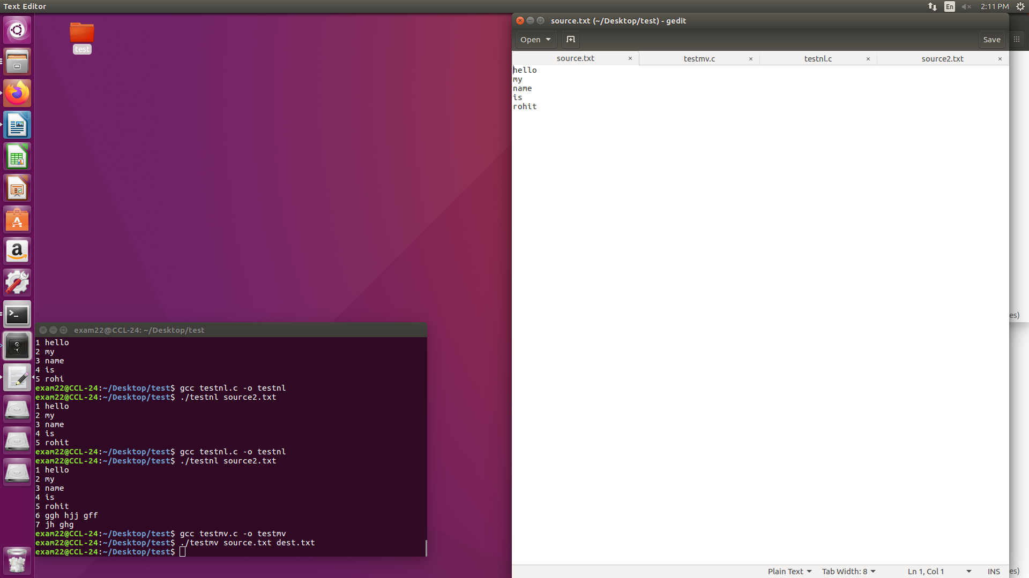

**command**

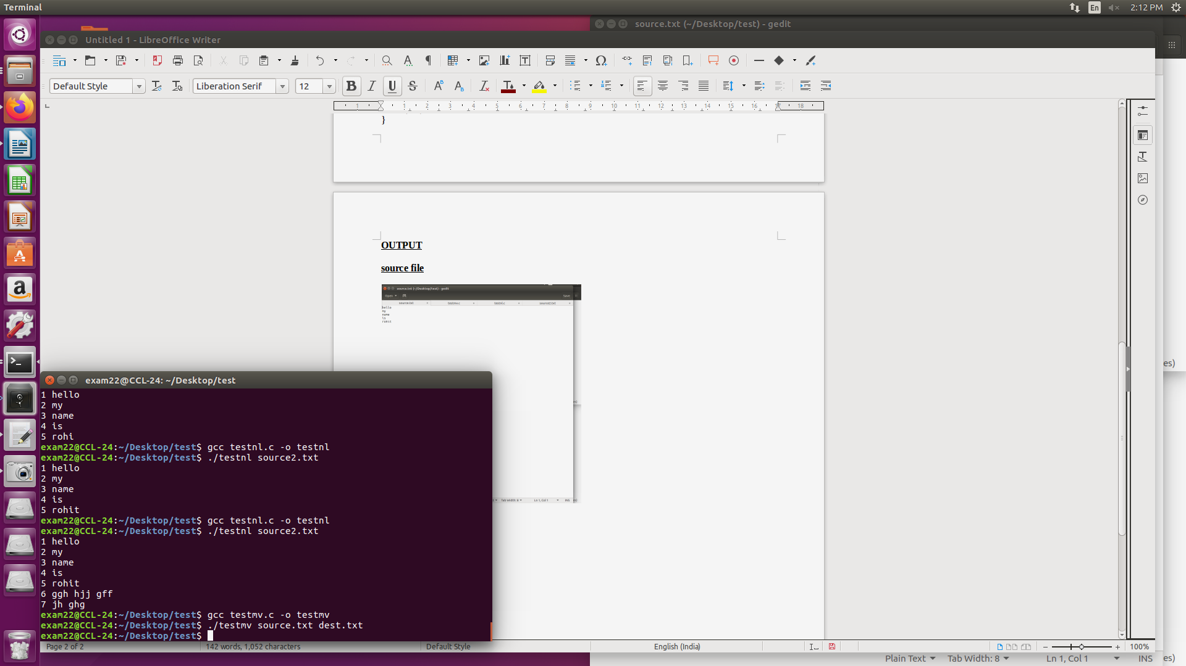

**dest file after execution**

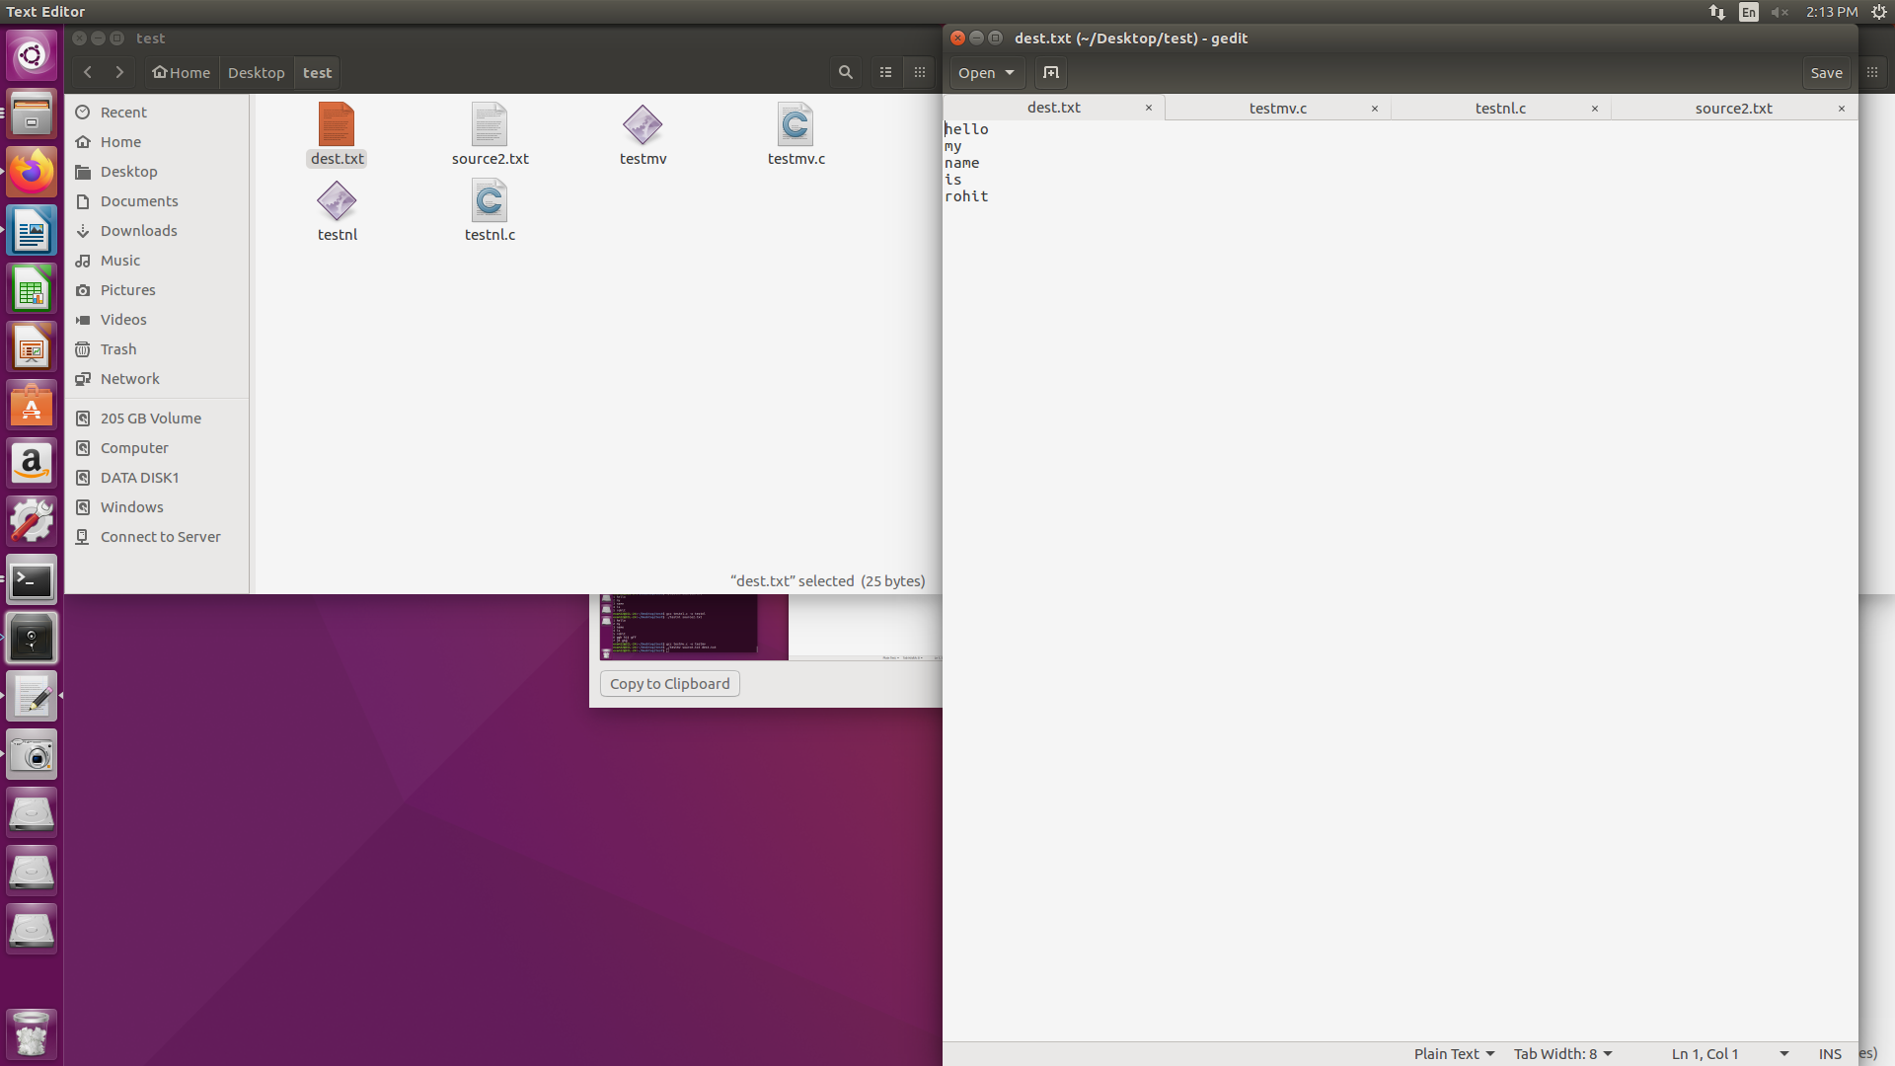

2)

**CODE**

#include<stdio.h>

#include<stdlib.h>

#include<unistd.h>

#include <sys/types.h>

#include <sys/stat.h>

#include <fcntl.h>

#include<string.h>

void main(int argc,char* argv[])

{

int fd1;

fd1=open(argv[1],O_RDONLY,666); //system call to open file

if(fd1==-1) // if -1, file not opened

{

printf("error opening file 1");

}

char buffer[10000]; //stores contents of the file

int bytesrd,count,i=0; //stores bytesread from file, count stores no of lines

while(bytesrd=read(fd1,buffer,10000)>0) //copies file contetns to buffer

{

}

printf("1 ");

for(i=0;i<strlen(buffer);i++)

{

printf("%c",buffer[i]);

if(buffer[i+1]!='\0') //to ensure the last \n is not counted

{

if(buffer[i]=='\n') //checks number of lines by checking number of new line prompts

{

count++;

printf("%d ",count+1);

}

}

}

}

**OUTPUT**

**source file**

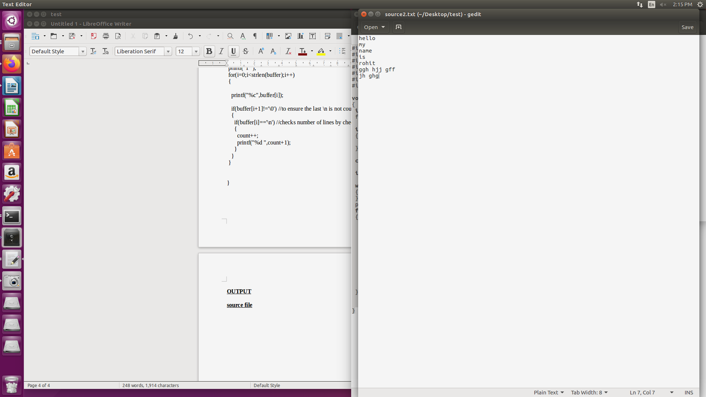

**command with output**

